Community Council Report

Llandow Ward

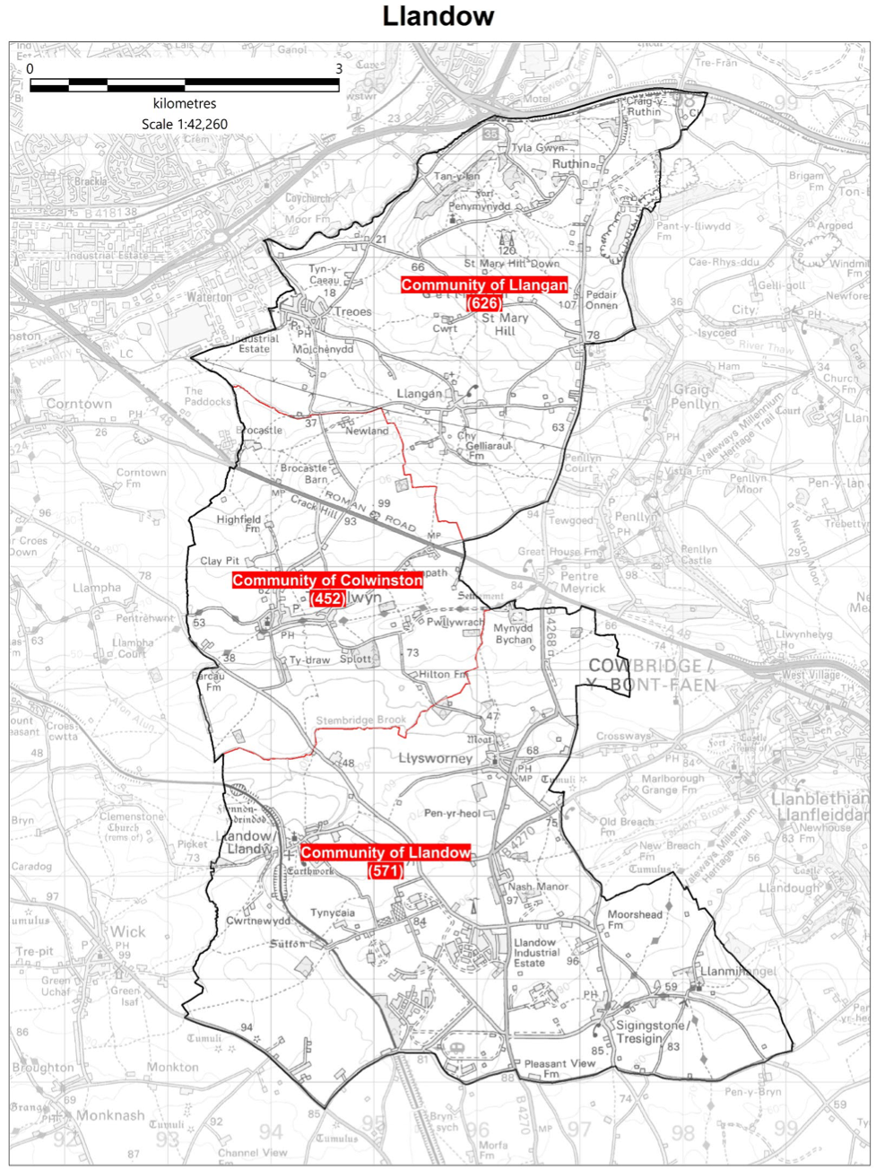

Cllr. Christine Cave email: cacave@valeofglamorgan.gov.uk

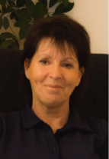

**Date: September 2024** Report to the Community Councils (CC) in the Llandow Ward: Colwinston; Llandow, Llysworney, Sigingstone, Sutton and Llangan/Treoes and St Mary Hill.

**Vale of Glamorgan Full Council meeting date to April 2025**

8th May Annual meeting

30th September, 2024

2nd December, 2024

3rd March, 2025

28th April, 2025

**Full Council meeting -**  MONDAY, 15TH JULY, 2024 AT 6.05 P.M.

HYBRID MEETING

Agenda

PART 1

1.         Apologies for absence.

[[View Minute](https://www.valeofglamorgan.gov.uk/Documents/_Committee%20Reports/Council/2024/24-07-15/Minutes.pdf)]

2.         (a)       To hear the roll call of Members.

            (b)       To receive declarations of interest and the nature of such interests under the Council’s Code of Conduct.

*(Note: Members seeking advice on this item are asked to contact the Monitoring Officer or Democratic Services at least 48 hours before the* meeting.)

[[[View Minute](https://www.valeofglamorgan.gov.uk/Documents/_Committee%20Reports/Council/2024/24-07-15/Minutes.pdf)]

3.         To approve the minutes of:

            (a)       the meeting held on [29th April, 2024](https://www.valeofglamorgan.gov.uk/Documents/_Committee%20Reports/Council/2024/24-04-29/Minutes.pdf); and

            (b)       the Annual Meeting held on [8th May, 2024](https://www.valeofglamorgan.gov.uk/Documents/_Committee%20Reports/Annual%20Meeting/2024/Minutes-and-DN.pdf).

[[View Minute](https://www.valeofglamorgan.gov.uk/Documents/_Committee%20Reports/Council/2024/24-07-15/Minutes.pdf)]

4.         To receive any announcements from the Mayor, Leader, Members of the Cabinet and the Chief Executive and to receive any petitions submitted by Members.

[[View Minute](https://www.valeofglamorgan.gov.uk/Documents/_Committee%20Reports/Council/2024/24-07-15/Minutes.pdf)]

5.         Questions from the Public –

[4 questions](https://www.valeofglamorgan.gov.uk/Documents/_Committee%20Reports/Council/2024/24-07-15/Public-Questions.pdf) have been received.  [Please note Questions 2 and 4 have been withdrawn]

[[View Minute](https://www.valeofglamorgan.gov.uk/Documents/_Committee%20Reports/Council/2024/24-07-15/Minutes.pdf)]

6.         To consider the following Notice of Motion [submitted by Councillors M. Cowpe and Dr. I.J. Johnson] –

Removal of Specialist Health Visiting Support for Breast or Combination Feeding

The Vale of Glamorgan Council notes with concern the proposals by Cardiff and Vale University Health Board to remove specialist health visiting support from the only drop-in service in the Vale of Glamorgan for parents who are breast or combination feeding, which is located in Dinas Powys.

The Vale of Glamorgan Council resolves to write to Cardiff and Vale UHB asking them to reconsider this proposal and to maintain the current level of service.

[[View Minute](https://www.valeofglamorgan.gov.uk/Documents/_Committee%20Reports/Council/2024/24-07-15/Minutes.pdf)]

7.         To consider the following Notice of Motion [submitted by Councillors M.J. Hooper and Dr. I.J. Johnson] –

Consultation on the Voting System used for Principal Council Elections

The Vale of Glamorgan Council notes the provisions within the Local Government and Elections (Wales) Act 2021 which allow for principal councils to change their voting system to adopt the single transferable vote system.

In order for Council to make an informed decision as to whether or not to adopt this voting system, Council agrees to open a consultation, under section 8 of the Act, with local electors, community councils within the area and such other persons as appropriate, so that Council can reach a decision prior to November 15th 2024 as to whether to enact any change ahead of the 2027 elections.

[[View Minute](https://www.valeofglamorgan.gov.uk/Documents/_Committee%20Reports/Council/2024/24-07-15/Minutes.pdf)]

References –

8.         [Draft Standards Committee Annual Report](https://www.valeofglamorgan.gov.uk/Documents/_Committee%20Reports/Council/2024/24-07-15/Ref-from-Stds-Draft-Stds-Cttee-Annual-Report.pdf) – Standards Committee: 10th June, 2024.

[[View Minute](https://www.valeofglamorgan.gov.uk/Documents/_Committee%20Reports/Council/2024/24-07-15/Minutes.pdf)]

9.         [Cardiff Capital Region City Deal – Joint Scrutiny Committee Nominated Deputy](https://www.valeofglamorgan.gov.uk/Documents/_Committee%20Reports/Council/2024/24-07-15/Ref-from-ER-CCRD-Joint-Scrutiny-Committee-Nominated-Deputy.pdf) – Environment and Regeneration Scrutiny Committee: 18th June, 2024.

[[View Minute](https://www.valeofglamorgan.gov.uk/Documents/_Committee%20Reports/Council/2024/24-07-15/Minutes.pdf)]

Report of the Chief Executive –

10.      [Use of the Chief Executive’s Emergency Powers](https://www.valeofglamorgan.gov.uk/Documents/_Committee%20Reports/Council/2024/24-07-15/Use-of-CXs-Emergency-Powers.pdf).

[[View Minute](https://www.valeofglamorgan.gov.uk/Documents/_Committee%20Reports/Council/2024/24-07-15/Minutes.pdf)]

Report of the Monitoring Officer / Head of Legal and Democratic Services –

11.      [Amendments to the Council’s Constitution](https://www.valeofglamorgan.gov.uk/Documents/_Committee%20Reports/Council/2024/24-07-15/Amendments-to-the-Council-Constitution.pdf).

[[View Minute](https://www.valeofglamorgan.gov.uk/Documents/_Committee%20Reports/Council/2024/24-07-15/Minutes.pdf)]

12.      To consider the following proposal(s) from the Executive in relation to the Council’s Policy Framework and Budget

|  |  |  |
| --- | --- | --- |
| Item | Date of Meeting | Minute No. |
| (a)         [Renewal of Public Space Protection Orders for the Prevention of Alcohol Related Anti-Social Behaviour](https://www.valeofglamorgan.gov.uk/Documents/_Committee%20Reports/Council/2024/24-07-15/Ref-from-Cab-Renewal-of-PSPO-Alcohol-ASB-Report-to-Cabinet.pdf)  ([View Reference](file:////Documents/_Committee%2520Reports/Council/2024/24-07-15/Ref-from-Cab-–-Renewal-of-PSPO-Alcohol-ASB.pdf))  [[View Minute](https://www.valeofglamorgan.gov.uk/Documents/_Committee%20Reports/Council/2024/24-07-15/Minutes.pdf)] | 11th July, 2024 | C |
| (b)         [Renewal of Public Space Protection Orders –  Dog Controls](https://www.valeofglamorgan.gov.uk/Documents/_Committee%20Reports/Council/2024/24-07-15/Ref-from-Cab-Renewal-of-PSPO-Dog-Controls-Report-to-Cabinet.pdf)  ([View Reference](file:////Documents/_Committee%2520Reports/Council/2024/24-07-15/Ref-from-Cab-–-Renewal-of-PSPO-Dog-Controls.pdf))  [[View Minute](https://www.valeofglamorgan.gov.uk/Documents/_Committee%20Reports/Council/2024/24-07-15/Minutes.pdf)] | 11th July, 2024 | C |

N.B.  The reports which are the subject of the references in respect of Agenda Items 12(a) and 12(b) above have already been circulated to Members with the Cabinet agenda for 11th July, 2024.

13.      To inform the Council of the Use of the Urgent Decision Procedure under Article 15.14 of the Constitution.

|  |  |  |
| --- | --- | --- |
| Item | Date of Meeting | Minute No. |
| (a)       [2024 Update to the Housing Support Grant Delivery Plan](https://www.valeofglamorgan.gov.uk/Documents/_Committee%20Reports/Council/2024/24-07-15/Ref-from-Cab-2024-Update-to-the-Housing-Support-Grant-Delivery-Plan.pdf) 2022-2025 (3)  [[View Minute](https://www.valeofglamorgan.gov.uk/Documents/_Committee%20Reports/Council/2024/24-07-15/Minutes.pdf)] | 23rd May, 2024 | C13 |
| (b)       [Housing Development Programme](file:////Documents/_Committee%2520Reports/Council/2024/24-07-15/Ref-from-Cab-Housing-Development-Programme-–-Land-at-Upper-Cosmeston-Farm-Penarth-Part-I.pdf) – Land at Upper Cosmeston Farm, Penarth (Part I) (4)  [[View Minute](https://www.valeofglamorgan.gov.uk/Documents/_Committee%20Reports/Council/2024/24-07-15/Minutes.pdf)] | 6th June, 2024 | C30 |
| (c)        [Housing Development Programme](file:////Documents/_Committee%2520Reports/Council/2024/24-07-15/Ref-from-Cab-Housing-Development-Programme-–-Land-at-Upper-Cosmeston-Farm-Penarth-Part-II.pdf) – Land at Upper Cosmeston Farm, Penarth (Part II) (4)  [[View Minute](https://www.valeofglamorgan.gov.uk/Documents/_Committee%20Reports/Council/2024/24-07-15/Minutes.pdf)] | 6th June, 2024 | C35 |
| (d)       [Renewal of Public Space Protection Orders for the Prevention of Alcohol Related Anti-Social Behaviour](https://www.valeofglamorgan.gov.uk/Documents/_Committee%20Reports/Council/2024/24-07-15/Ref-from-Cab-Renewal-of-PSPO-Alcohol-ASB-Report-to-Cabinet.pdf) ([View Reference](file:////Documents/_Committee%2520Reports/Council/2024/24-07-15/Ref-from-Cab-–-Renewal-of-PSPO-Alcohol-ASB.pdf))  [[View Minute](https://www.valeofglamorgan.gov.uk/Documents/_Committee%20Reports/Council/2024/24-07-15/Minutes.pdf)] | 11th July, 2024 | C |
| (e)       [Renewal of Public Space Protection Orders –  Dog Controls](https://www.valeofglamorgan.gov.uk/Documents/_Committee%20Reports/Council/2024/24-07-15/Ref-from-Cab-Renewal-of-PSPO-Dog-Controls-Report-to-Cabinet.pdf) ([View Reference](file:////Documents/_Committee%2520Reports/Council/2024/24-07-15/Ref-from-Cab-–-Renewal-of-PSPO-Dog-Controls.pdf))  [[View Minute](https://www.valeofglamorgan.gov.uk/Documents/_Committee%20Reports/Council/2024/24-07-15/Minutes.pdf)] | 11th July, 2024 | C |

14.      To [receive questions](https://www.valeofglamorgan.gov.uk/Documents/_Committee%20Reports/Council/2024/24-07-15/Questions.pdf) and answers pursuant to Section 4.19.2 – 4.19.9 of the Council’s Constitution (i.e. questions on any matter in relation to which the Council has powers or duties or which affects the Vale of Glamorgan).

[[View Minute](https://www.valeofglamorgan.gov.uk/Documents/_Committee%20Reports/Council/2024/24-07-15/Minutes.pdf)]

**Members of the Cabinet**

Councillor L. Burnett (Executive Leader and Cabinet Member for Performance and Resources) – **Labour Party**

Councillor B.E. Brooks (Deputy Leader and Cabinet Member for Sustainable Places) – **Labour Party**

Councillor R.M. Birch (Cabinet Member for Education, Arts and the Welsh Language) – **Labour Party**

Councillor M.R. Wilson (Cabinet Member for Neighbourhood and Building Services) **Labour Party**

Councillor M.R. Wilkinson (Cabinet Member for Public Sector Housing and Tenant Engagement) **Labour Party**

Councillor E. Williams (Cabinet Member for Social Care and Health) **Llantwit First Party**

Councillor S. Sivagnanam (Cabinet Member for Community Engagement, Equalities and Regulatory Services) **Labour Party**

Councillor G. John (Cabinet Member for Leisure, Sport and Well-being) **Llantwit First Party**

**Cabinet meetings:**

18th July 2024 available at:

<https://www.valeofglamorgan.gov.uk/Documents/_Committee%20Reports/Cabinet/2024/24-07-18/Minutes.pdf>

11th July 2024 available at:

<https://www.valeofglamorgan.gov.uk/Documents/_Committee%20Reports/Cabinet/2024/24-07-11/Minutes.pdf>

**Consultations - Vale of Glamorgan Council**

Current consultations are available at: <https://participate.valeofglamorgan.gov.uk>

* **[Placemaking](https://participate.valeofglamorgan.gov.uk/placemaking" \t "_self)**

**[Welcome to our Placemaking hub, a platform for you to share your views on how to improve our town...](https://participate.valeofglamorgan.gov.uk/placemaking" \t "_self)**

* **Submit a petition (including e-petition)**

**Creating or taking part in a petition is one way you can get involved in what the Council does. It allows you to raise issues of concern, giving Councillors the opportunity to consider the need for change.**

[**Create or sign a petition**](https://participate.valeofglamorgan.gov.uk/e-petition)

**Local Matters**

## Colwinston/Llangan/Llandow – Local Democracy Boundary Commission review of Town and Community Councils– letter of objection sent – response from the Welsh Government minister has not been received – ongoing.

## Colwinston – Adoption of the vines – ongoing

* Colwinston – Village Hall roof repairs and possible transfer of assets – ongoing
* Colwinston – request to replenish green food waste bags – bags delivered (more available on request)
* Colwinston – Section 106 money – request for bench to reflect Colwinston’s “Thankful Village”. Bench location and design decided and request to move bin by school – ongoing.
* Colwinston/Llandow/Llangan –Work to repair the road access to the recycling centre completed.
* Llandow – Council tax issue raised regarding local holiday let – resolved.
* Llandow – Field run off meeting held at the end of January with a further meeting of the Llandow Action Group to be held in the Autumn – ongoing.
* Llangan/Llandow – Speeding traffic is an ongoing issue with Welsh Government undertaking a review of the 20 mph. Until this is resolved there has been little activity with Go-Safe – ongoing.
* Llangan – Japanese Knotweed reported – clearance will start in September with landowner contacted where it exists beyond the highway verge – ongoing.
* Llangan/Colwinston/Llandow issues raised with Rob Thomas regarding the re-banding of homes in the ward – ongoing
* Llandow – Fly tipping cases reported to the VoG and actioned. A request was also made again for camera’s to be located in the area – ongoing.
* Llandow – Poor state of the play area in Llandow reported in October 2023 and we are still waiting for the matter to be resolved. Emailed again recently as the playground is fly infested and still in a poor state of repair – ongoing.
* Llandow – Drainforce issue raised with VoG – reply received and Drainforce informed.
* Llandow – issues raised with Network rail - ongoing
* Llangan – Fly tipping and speeding traffic issues were raised again with the VoG and a request for camera surveillance on the road from the A48 leading to Treoes has been made - ongoing
* Llangan – Gypsy traveler item raised with VoG – ongoing.

## **Scheduled Meetings for June 2024 - All Meetings commence at 6.00 p.m. and will be held virtually unless otherwise stated.**

## 

|  |  |  |  |
| --- | --- | --- | --- |
| Council |  | Early Retirement/Redundancy (10.00 a.m.) | 20 Jun |
| Annual Meeting |  | Licensing - Public Protection (10.00 a.m.) | 11 Jun |
| Cabinet (2.00 p.m.)[[View Live Stream - 6 June](https://youtube.com/live/iw5TEbK2Z3k)] | [6 Jun](https://www.valeofglamorgan.gov.uk/en/our_council/Council-Structure/minutes,_agendas_and_reports/agendas/cabinet/2024/24-06-06.aspx);20 Jun | Licensing - Statutory |  |
| Scrutiny (Corporate Performance and Resources) | 19 Jun | Licensing Sub (10.00 a.m.) | 21 Jun |
| Scrutiny (Environment and Regeneration) | 18 Jun | Planning (4.00 p.m.)[[View Live Stream - 13 June](https://youtube.com/live/Pz2d68SPgtk)] | [13 Jun](https://www.valeofglamorgan.gov.uk/en/our_council/Council-Structure/minutes,_agendas_and_reports/agendas/planning/2024/24-06-13.aspx) |
| Scrutiny (Healthy Living and Social Care) (5.00 p.m.)[[View Live Stream - 11 June](https://youtube.com/live/oAyMEHQeanU?feature=share)] | [11 Jun](https://www.valeofglamorgan.gov.uk/en/our_council/Council-Structure/minutes,_agendas_and_reports/agendas/Scrutiny-HLSC/2024/24-06-11.aspx) | Public Rights of Way |  |
| Scrutiny (Homes and Safe Communities)[[View Live Stream - 12 June](https://www.youtube.com/live/kUp7BYmmM0E?si=8CjOqwFY_3AeG0Aq)] | [12 Jun](https://www.valeofglamorgan.gov.uk/en/our_council/Council-Structure/minutes,_agendas_and_reports/agendas/Scrutiny-HSC/2024/24-06-12.aspx) | Senior Management Appointment (1.30 p.m.)[[View Live Stream - 4 June](https://youtube.com/live/dYDOMDCLlQY?feature=share)] | [4 June](https://www.valeofglamorgan.gov.uk/en/our_council/Council-Structure/minutes,_agendas_and_reports/agendas/senior_management_appointment/2024/24-06-04.aspx) |
| Scrutiny (Learning and Culture) | 10 Jun27 Jun | Standards (10.00 a.m.) | [10 June](https://www.valeofglamorgan.gov.uk/en/our_council/Council-Structure/minutes,_agendas_and_reports/agendas/standards/2024/24-06-10.aspx);18 June |
| Appeals |  | Trust |  |
| Governance and Audit | 17 Jun | Vale of Glamorgan Local Access Forum |  |
| Community Liaison |  | Voluntary Sector Joint Liaison | 24 Jun |
| Democratic Services (4.00 p.m.) |  | Welsh Church Act Estate (4.00 p.m.) | 3 Jun |
| Investigating |  | Shared Regulatory Services Joint Committee (10.00 am) | 19 Jun |

## 

## 

## 